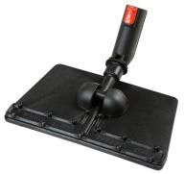

|  |  |  |  |
| --- | --- | --- | --- |
| AC8000016 | | Nástavec na mop 39 cm | 990,- |
| AC0020002 | http://www.ksgsteamdivision.com/var/sito/storage/images/prodotti/accessori/vapore-e-aspirazione/panno-per-floor-mop/5853-13-eng-GB/58-Microfober-cloth-for-floor-mop.jpg | Hadr mopovací 39 cm | 290,- |
| AC8000040 | http://www.ksgsteamdivision.com/var/sito/storage/images/prodotti/accessori/vapore-e-aspirazione/floor-steam-mop-39-cm/5845-5-eng-GB/Floor-steam-mop-39-cm.jpg | Nástavec na mop 25 cm | 850,- |
| AC0020001 | http://www.ksgsteamdivision.com/var/sito/storage/images/prodotti/accessori/vapore-e-aspirazione/panno-per-floor-mop/5853-13-eng-GB/58-Microfober-cloth-for-floor-mop.jpg | Hadr mopovací 25 cm | 250,- |

Ceny bez DPH